**Ideation Phase**

**Define the Problem Statements**

|  |  |
| --- | --- |
| **Date** | **21-october-2022** |
| **Team ID** | PNT2022TMID45711 |
| **Project Name** | Project – Natural Disaster Intensity  Analysis and Classification Using  Artificial Intelligence |
| **Maximum Marks** | 2 Marks |

**Customer Problem Statement Template:**

Create a problem statement to understand your customer's point of view. The Customer Problem Statement template helps you focus on what matters to create experiences people will love.

A well-articulated customer problem statement allows you and your team to find the ideal solution for the challenges your customers face. Throughout the process, you’ll also be able to empathize with your customers, which helps you better understand how they perceive your product or service.

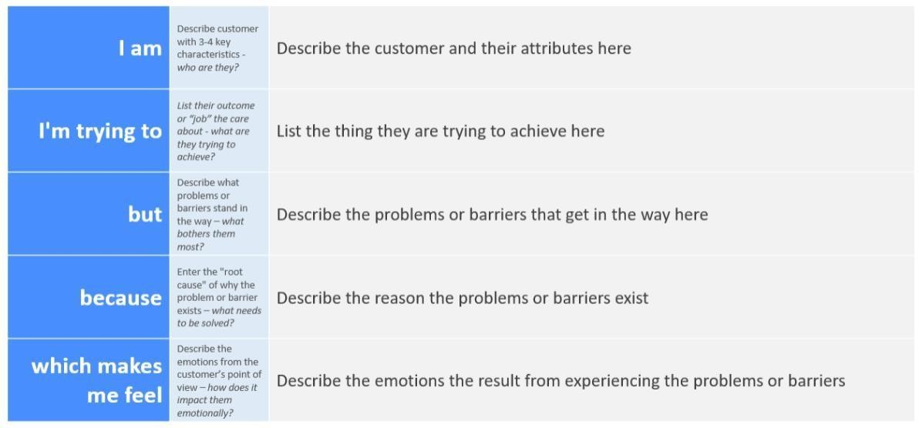

**Problem Statement for “Natural Disaster Intensity Analysis and Classification using Artificial Intelligence.”**  **PROBLEM STATEMENT 1:**

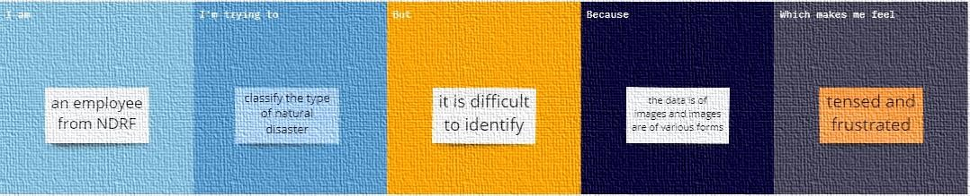

**PROBLEM STATEMENT 2:**

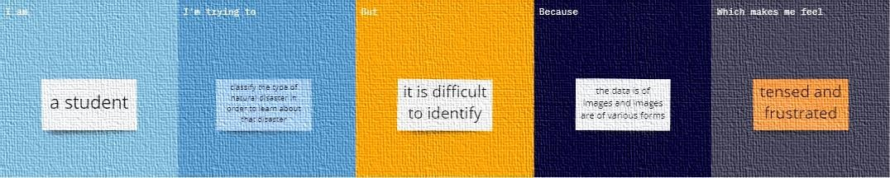

|  |  |  |  |  |  |
| --- | --- | --- | --- | --- | --- |
| **Problem**  **Statement**  **(PS)** | **I am**  **(Customer)** | **I’m trying**  **to** | **But** | **Because** | **Which makes me**  **feel** |
| Problem  Statement-1 | An employee from NDRF | Classify the type of natural disaster | It is difficult to identify | The data is of images and images are of various forms | Tensed and frustrated |
| Problem  Statement-2 | A student | Classify the type of natural disaster in order to learn about that disaster | It is difficult to identify | The data is of images and images are of various forms | Tensed and frustrated |

**Team Members:**

**RAMPA NATHAN [6113191031078] SAMPATH [6113191031081]**

**VIGNESH [6113191031117] THOUFEEQ [6113191031111]**